SILo: Sistem Informasi Logistik

Use Case Specification: Lihat Daftar Item

Version 1.0

Revision History

|  |  |  |  |
| --- | --- | --- | --- |
| **Date** | **Version** | **Description** | **Author** |
| 01 Okt 2020 | 1.0 | Initiation | Daniel Siahaan |
|  |  |  |  |
|  |  |  |  |
|  |  |  |  |

Table of Contents

1. Insert Metadata 4

1.1 Brief Description 4

2. Flow of Events 4

2.1 Basic Flow 4

2.2 Alternative Flows 4

2.3 Exceptions 4

3. Special Requirements 4

4. Pre-Conditions 4

5. Post-Conditions 4

6. Extension Points 5

Use Case Specification: Lihat Daftar Item

# Insert Metadata

## Brief Description

This use case describes how the booker view the list of items in the catalog. After viewing the list, the booker can manage each items

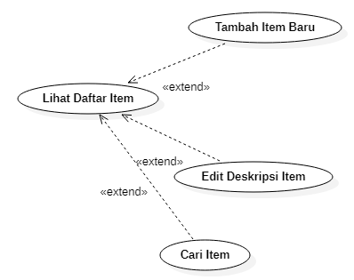

# Flow of Events

## Basic Flow

1. In the main page, Booker clicks **Items** menu.

2. The system shows the list of items.

## Alternative Flows

n.a.

## Exceptions

2a.3a If any required field is empty, the system fails to create the new item.

2a.3a.1 The system shows a dialog box to ask the booker whether to cancel the creation of the new item or reenter the data.

2a.3a.2 Booker clicks on cancel button.

# Special Requirements

1. Only authorized and authenticated booker may create new item.
2. The fields shown in the list of items should at least contains the following information: id, title, manufacturer, number of stocks
3. An item should have the following information: id, barcode, title, description, manufacturer, and url.

# Pre-Conditions

1. The system contains a set of metadata of articles previously inserted.

# Post-Conditions

1. A new metadata of article has been added to the database.

# Extension Points

2a Booker can **Add New Item**.

2a.1 Booker click on Add button.

2a.2 The system shows the new item form

2a.3 Booker fills the form, then click submit.

2a.4 The system shows the refreshed list items where the new item has been added.

2b The Booker can **Edit Item Description** to update a specific information of the item.

2b.1 The Booker click on **Edit** button of corresponding item.

2b.2 The system shows the edit item form.

2b.3 The booker edit the necessary field, then click the **Update** button.

2b.4. The system shows the refreshed list items where the edited item has been refreshed.

2c The Booker can **Search Item** to find items that matched specific keywords.

2c.1 The Booker fill the keywords, then clicks the **Search** button.

2c.2 The system shows the list of matched items.